Group 2
Bob Loth
Seth Weiland
Project Report

Our group will be building a small-scale, text-based Pokémon battle simulation. We currently envision our project as containing a base class Pokémon, which will provide data members for various stats, and an internal struct for each Pokémon’s moves, which will contain various stats for each move. The Pokémon base class will contain functions that use a simplified version of formulas from the games to determine the damage given or taken. Each Pokémon will have its own class, in which a virtual function implementing the behavior of each Pokémon’s passive effects will be defined. The program is designed to allow the quick addition of any number of Pokémon. They can have new moves, new special effects emplaced in their makeAttack and takeDamage function implementations, and new default stats.

The main parts of the program are as follows: the main loop, the Pokémon base class, and derived classes from Pokémon. For this example, four derived classes were created: Pikachu, Bulbasaur, Charmander, and Squirtle.

Class Parameters:
In our implementation, all Pokémon have:
- A name, used to display their name in the main loop
- A type, used in damage calculations to determine the effectiveness of a move
- An amount of starting hitpoints. This decreases (or increases) during the a match
- An amount of attack power. This is factored into the damage the Pokémon deals when making attacks.
- An amount of defense power. This is factored into the damage the Pokémon takes when defending against an opposing Pokémon’s attacks.
- An amount of speed. This is used when comparing Pokémon during the main loop to determine which Pokémon gets to make the first move.
- A list of 4 Moves.
Moves are an internal struct, used by the Pokémon class. Moves have:
  - A name, used to display the move’s name in the main loop.
  - A power level, used in the damage calculation
  - An accuracy, used to determine whether a move hits an opposing Pokémon or not
  - A type, used in damage calculations to determine the effectiveness of a move
  - A default constructor, and
  - A constructor that initializes all 4 parameters.

Class Functions and the TypeList:

All Pokémon share a list of effectiveness values. These values, along with the type relationships they represent are implemented as an unordered map of maps named TypeList. The first parameter in the TypeList is the type of the attacking Move. The second parameter is the type of the defending Pokémon. Type relationships deemed “super effective”, based on the mechanics from the game series, are assigned a value of 2.0. “not very effective” are assigned 0.5. Most other values are assigned 1.0, with a few 0.0 exceptions, modelling complete immunity to that type. These values stored in TypeList are accessed and used in MakeAttack as a damage multiplier. In the games, this system enforces variety in both Pokémon type selection, and move type selection. For the purposes of this demonstration, only a few types are used, but there exists support for all 18 types.

Each Pokémon has 4 main functions:
- Virtual MakeAttack: takes an attack from the Pokémon’s moveList, and the opposing Pokémon’s type, and returns a raw-damage value, which is then passed to the opposing Pokémon’s takeDamage function. It uses a simplified form of the damage calculation used in the games.
- Virtual takeDamage: This simply takes a raw damage value, divides it by the Pokémon’s defense, and subtracts the resulting value from the Pokémon’s hitpoints.
- getType : returns the Pokémon’s type.
- getName : returns the Pokémon’s name.
- overloaded > operator: Returns true if the first Pokémon’s speed is greater than the second Pokémon’s speed, and false otherwise.

Main:
Initialize two additional pointers p1 and p2 as nullptr.
Use a switch structure to point p1 to the first selected Pokémon.
Use a switch structure to point p2 to the second selected Pokémon.
Compare p1 and p2 to determine precedence.

If p1 > p2
Start loop
Output name, prompt, and 4 choices of attack
P1 uses makeAttack to pass raw damage value to a takeDamage function called by P2.
Check if P2’s hp < 0. If P2’s hp < 0, break the loop
Continue loop
Report winner as the p whose hp > 0
If p2 >= p1
Start loop
Output name, prompt, and 4 choices of attack
P2 uses makeAttack to pass raw damage value to a takeDamage function called by P1.
Check if P1’s hp < 0. If P1’s hp < 0, break the loop
Continue loop
Report winner as the p whose hp > 0

Final Thoughts, Improvements
This project was very fun to implement, and used a familiar setting to demonstrate some of the power of the concepts we learned in the class. Currently, the main algorithm does not handle a pokemon’s change in speed due to a special effect very well. While this is not an issue currently, as there are no cases where the problem would occur with our current Pokemon, We had to cut some corners, as the damage formula includes some additional parameters that were outside our planned project scope of one base class, several derived classes. We also restricted ourselves to damaging moves only. The Pokémon games do have moves that have special effects, but they are varied enough in their effects that narrowing down a single approach to implement support for all the potential effects would take time away from building our basic functionality. An additional factor that we could implement could be use items, that can be an option in combat instead of a
move. As of now, the program allows for one Pokémon per side, per battle. We could implement a Trainer class, to hold up to 6 Pokémon objects, a few status flags, and a map of use items. Not counting those exceptions, the formula and gameplay pattern are almost identical to some of the original games.

Visualization of the TypeList
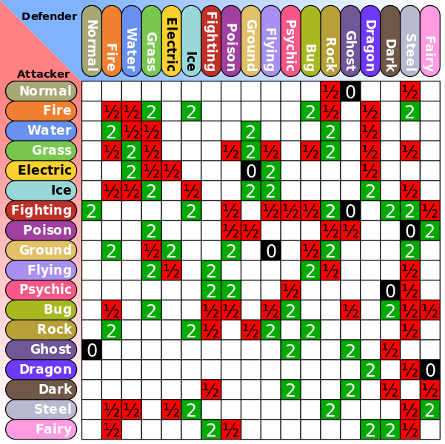
This Photo by Unknown Author is licensed under CC BY-SA

Visualization of the current inheritance tree

